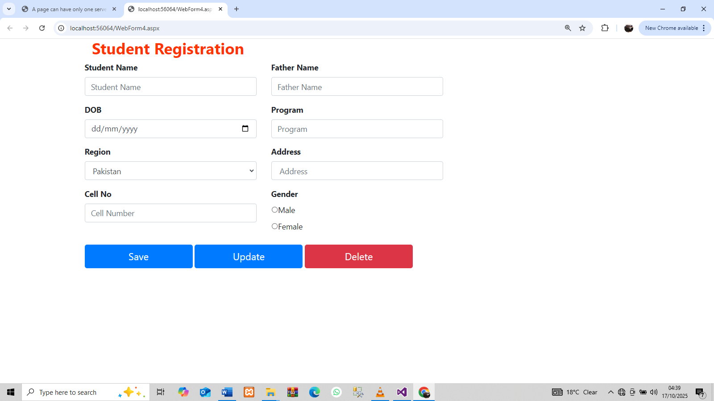

<%@ Page Language="C#" AutoEventWireup="true" CodeBehind="WebForm4.aspx.cs" Inherits="SHOPPING_WEB_APPLICATION.WebForm4" %>

<!DOCTYPE html>

<html xmlns="http://www.w3.org/1999/xhtml">
<head runat="server">
<title></title>
<link href="css/bootstrap.min.css" rel="stylesheet" />
<link href="Style2.css" rel="stylesheet" />

<style type="text/css">
.auto-style1 {
color: #FF3300;
font-size: xx-large;
}
</style>

</head>
<body>
<div class="container"
<form id="form1" runat="server">
<div>
<section id="main-content">
<section class="wrapper">
<div class="row">
<div class="col-lg-12">
<section class="panel">
<header class="panel-heading">
<div class="col-md-4 col-md-offset-4">
<h1 class="auto-style1"><strong>Student Registration</strong></h1>
</div>
</header>
<div class="panel-body">
<div class="row">
<div class="col-md-4 col-md-offset-1">
<div class="form-group">
<asp:Label runat="server" AssociatedControlID="txtStdname"><b>Student Name</b></asp:Label><br />
<asp:TextBox runat="server" required="required" Enabled="True" name="BrandName" ID="txtStdname" class="form-control input-sm" placeholder="Student Name"></asp:TextBox>
</div>
</div>
<div class="col-md-4 col-md-offset-1">
<div class="form-group">
<asp:Label runat="server" AssociatedControlID="txtfname"><b>Father Name</b></asp:Label><br />
<asp:TextBox runat="server" required="required" Enabled="True" name="BrandName" ID="txtfname" class="form-control input-sm" placeholder="Father Name"></asp:TextBox>
</div>
</div>
</div>
<div class="row">
<div class="col-md-4 col-md-offset-1">
<div class="form-group">
<asp:Label runat="server" AssociatedControlID="txtdob"><b>DOB</b></asp:Label><br />
<asp:TextBox runat="server" required="required" TextMode="Date" Enabled="True" name="BrandName" ID="txtdob" class="form-control input-sm" placeholder="DOB "></asp:TextBox>
</div>
</div>
<div class="col-md-4 col-md-offset-1">
<div class="form-group">
<asp:Label runat="server" AssociatedControlID="txtprogram" ><b>Program</b></asp:Label><br />
<asp:TextBox runat="server" required="required" Enabled="True" name="BrandName" ID="txtprogram" class="form-control input-sm" placeholder="Program"></asp:TextBox>
</div>
</div>
</div>
<div class="row">
<div class="col-md-4 col-md-offset-1">
<div class="form-group">
<asp:Label runat="server" AssociatedControlID="txtregion"><b>Region</b></asp:Label><br />
<asp:DropDownList ID="txtregion" CssClass="form-control input-sm" runat="server" >
<asp:ListItem Text="Pakistan" />
<asp:ListItem Text="Iran" />
<asp:ListItem Text="Iraq" />
<asp:ListItem Text="Turkey" />
<asp:ListItem Text="India" />
<asp:ListItem Text="China" />
</asp:DropDownList>
</div>
</div>
<div class="col-md-4 col-md-offset-1">
<div class="form-group">
<asp:Label runat="server" AssociatedControlID="txtaddress"><b>Address</b></asp:Label><br />
<asp:TextBox runat="server" required="required" Enabled="True" name="BrandName" ID="txtaddress" class="form-control input-sm" placeholder=" Address "></asp:TextBox>
</div>
</div>
</div>
<div class="row">
<div class="col-md-4 col-md-offset-1">
<div class="form-group">
<asp:Label runat="server" AssociatedControlID="txtcell"><b>Cell No</b></asp:Label><br />
<asp:TextBox runat="server" required="required" TextMode="Number" Enabled="True" name="BrandName" ID="txtcell" class="form-control input-sm" placeholder="Cell Number "></asp:TextBox>
</div>
</div>
<div class="col-md-4 col-md-offset-1">
<div class="form-group">
<asp:Label runat="server" AssociatedControlID="txtgender" ><b>Gender</b></asp:Label><br />
<asp:RadioButtonList CssClass="form-group" ID="txtgender" runat="server">
<asp:ListItem Text="Male" />
<asp:ListItem Text="Female" />
</asp:RadioButtonList>
</div>
</div>
</div>
<div class="row">
<div class="col-md-10 col-md-offset-1">
<div class="form-group">
<%-- <asp:Button Text="Save" ID="btnsave" OnClick="btnsave_Click" CssClass="btn btn-primary btn-lg" Width="220px" runat="server" /> --%>

<asp:Button Text="Save" ID="btnsave" CssClass="btn btn-primary btn-lg" Width="220px" runat="server" />
<%-- <asp:Button Text="Update" ID="btnupdate" OnClick="btnupdate_Click" CssClass="btn btn-primary btn-lg" Width="220px" runat="server" /> --%>
<asp:Button Text="Update" ID="btnupdate" CssClass="btn btn-primary btn-lg" Width="220px" runat="server" OnClick="btnupdate_Click" />
<%-- <asp:Button Text="Delete" ID="btndlt" OnClick="btndlt_Click" CssClass="btn btn-danger btn-lg" Width="220px" runat="server" /> --%>
<asp:Button Text="Delete" ID="btndlt" CssClass="btn btn-danger btn-lg" Width="220px" runat="server" />
<asp:Label Text="" ForeColor="Green" Font-Bold="true" ID="lblmessage" CssClass="label label-success" runat="server" />
</div>
</div>
</div>
<div class="row">
<div class="col-md-10 col-md-offset-1">
<div class="form-group">
<div class="table-responsive">
<%-- <asp:GridView ID="gv" Width="100%" AutoGenerateSelectButton="true" SelectedRowStyle-BackColor="Green" OnSelectedIndexChanged="gv_SelectedIndexChanged" runat="server"></asp:GridView> --%>
</div>
</div>
</div>
</div>
</div>
</section>
</div>
</div>
</section>
</section>
</div>
</form>
</div>
</body>
</html>

<script src="https://unpkg.com/sweetalert/dist/sweetalert.min.js"></script>
<script src="css/sweetalert.min.js"></script>

ClientScript.RegisterClientScriptBlock(this.GetType(), "alert",
"swal('Succesfully Submited your work !')",true);
//"swal('Succesfully Submited your work !','success')",true);

